Problem Statement

Build the linear regression model using scikit learn in boston data to predict 'Price' based on other dependent variable.

Here is the code to load the data

import numpy as np

import pandas as pd

import scipy.stats as stats

import matplotlib.pyplot as plt

import sklearn from sklearn.datasets

import load_boston boston = load_boston()

bos = pd.DataFrame(boston.data)

**##Boston Dictionary Keys**

boston.keys()

op1.PNG

boston.data.shape

op2.PNG

print(boston.feature_names)

op3.PNG

print (boston.DESCR)

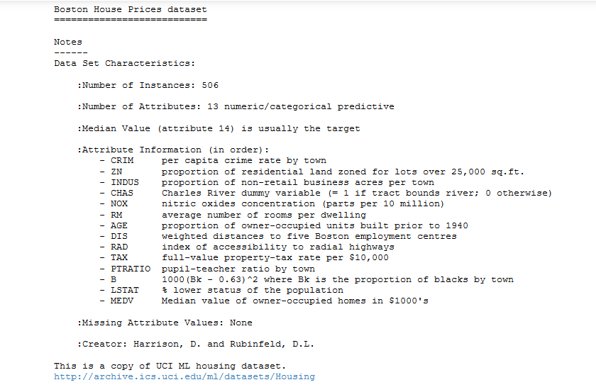

bos.head()

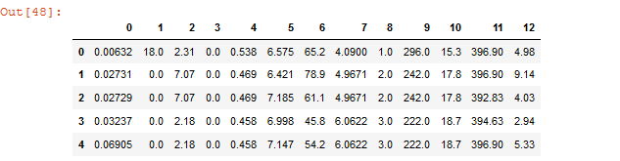

bos.columns = boston.feature_names

bos.head()

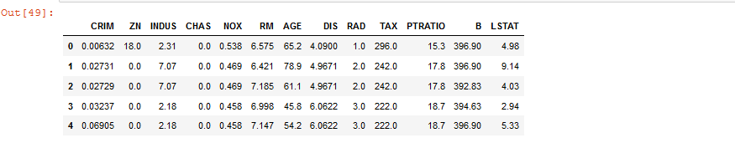

boston.target[:5]

op7.PNG

bos["PRICE"] = boston.target

bos.head()

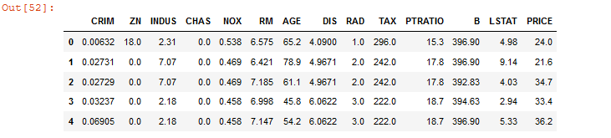

#Skikit learning

from sklearn.linear_model import LinearRegression

X = bos.drop('PRICE', axis = 1)

#linear object

lm = LinearRegression()

lm.fit(X,bos.PRICE)

op9.PNG

#Intercept and coefficients

print("Estimated intercept coefficient:",lm.intercept_)

op10.PNG

print("number of coefficients:",len(lm.coef_))

op11.PNG

#column 0 is 'features' and 1 is 'estimated coefficients'

pd.DataFrame(list(zip(X.columns, lm.coef_)))

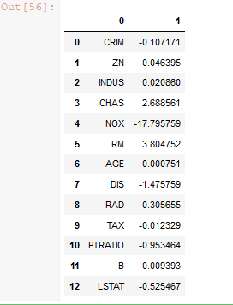

#plot between true housing prices and true RM

plt.scatter(bos.RM, bos.PRICE)

plt.xlabel("Average number of rooms per dwelling(RM)")

plt.ylabel("Housing price")

plt.title("Relationship between RM and Price")

plt.show()

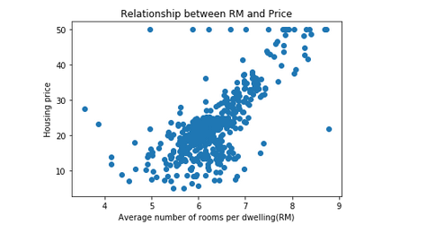

#predicting prices for first 25 houses

lm.predict(X)[0:25]

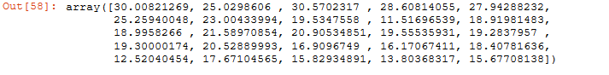

#plot between true prices and predicted prices

plt.scatter(bos.PRICE, lm.predict(X))

plt.xlabel("True Prices: $Y_i$")

plt.ylabel("Predicted prices: $\hat{Y}_i$")

plt.title("True prices vs Predicted prices:")

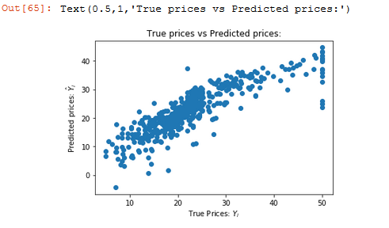

#Mean Squared Error

mseFull = np.mean((bos.PRICE - lm.predict(X))**2)

print(mseFull)

op16.PNG

#Train-test split

from sklearn.cross_validation import cross_val_score

X_train, X_test, Y_train, Y_test = sklearn.cross_validation.train_test_split(X, bos.PRICE, test_size=0.33, random_state= 5)

print("Fit a model X_train, and calculate MSE with Y_train:", np.mean((Y_train-lm.predict(X_train))**2))

print("Fit a model X_train, and calculate MSE with X_test, Y_test:",np.mean(Y_test - lm.predict(X_test))**2)

op17.PNG

#Residuals vs Residual plot (blue) Training and (green) tezt data

plt.scatter(lm.predict(X_train),lm.predict(X_train) - Y_train,c='b',s=40,alpha=0.5)

plt.scatter(lm.predict(X_test),lm.predict(X_test) - Y_test,c='g',s=40)

plt.hlines(y = 0, xmin = 0, xmax = 50)

plt.title("Residual plot using training(blue) and test(green) data")

plt.ylabel("Residuals")

